Design and Development of a Real-Time Flow-Based Intrusion Detection and Security Management System Using a Two-Stage Ensemble Model
Jimson A. Olaybar¹, Patrick D. Cerna²

^{1,2}College of ICT and Engineering, State University of Northern Negros, Sagay City, Negros Occidental, Philippines
¹FCSIT, Southern Leyte State University – Main Campus, Sogod, Southern Leyte, Philippines

¹jolaybar@southernleytestateu.edu.ph

Abstract— The increasing complexity of modern network environments has heightened the need for practical and scalable intrusion detection solutions. This study presents the development of a real-time, flow-based Intrusion Detection and Security Management System (IDSMS) that integrates live traffic monitoring, machine learning-based intrusion analysis, centralized data storage, and web-based visualization. The system captures network traffic from a MikroTik-based gateway using a passive flow sniffer deployed on a Kali Linux monitoring node. Packets are aggregated into bidirectional flows and transformed into statistical feature vectors, which are analyzed by a machine learning inference service through an application programming interface. Detection results, including risk level and attack classification, are stored in a centralized database and presented through an interactive dashboard. Development-stage testing using simulated attack traffic demonstrates the system’s ability to capture, analyze, and visualize network threats in real time. The proposed system provides a practical foundation for deployment in shared-access networks, small enterprises, and IoT-enabled environments.

Keywords— Intrusion Detection System, Flow-Based Analysis, Machine Learning, Network Security, Real-Time Monitoring
INTRODUCTION
The rapid growth of networked systems, including enterprise networks, Internet cafés, public Wi-Fi services, and IoT-enabled environments, has significantly increased exposure to cyber threats. Modern attacks such as port scanning, brute-force login attempts, DNS amplification, and distributed denial-of-service (DDoS) attacks continue to evolve in scale and sophistication, making traditional signature-based intrusion detection systems (IDS) insufficient for real-time protection [1], [4].
Recent studies emphasize the effectiveness of flow-based intrusion detection, which analyzes statistical properties of network flows rather than packet payloads. This approach enables efficient monitoring of encrypted traffic while reducing computational overhead, making it suitable for real-time and resource-constrained environments [2], [3], [7]. Machine learning (ML) and deep learning techniques further enhance flow-based IDS by learning complex traffic patterns and improving anomaly detection accuracy [6], [14], [22].
Despite advances in detection models, many existing IDS studies focus primarily on offline datasets and lack full system integration, limiting their applicability in operational networks [4], [10]. Real-world deployment requires not only accurate models but also live traffic capture, scalable inference, centralized logging, and actionable security management interfaces. Furthermore, public-access networks such as pisonet or shared Wi-Fi services demand IDS solutions capable of identifying malicious client devices while preserving normal user traffic. Recent studies have demonstrated the feasibility of anomaly detection and traffic pattern analysis in real-world Pisonet environments using dynamic time warping and seasonal decomposition techniques [25], [26].
To address these challenges, this study presents the development and implementation of a real-time flow-based Intrusion Detection and Security Management System (IDSMS). The proposed system integrates live network traffic capture, flow-level feature extraction, machine learning-based attack classification, and a web-based security management platform. The system is designed to operate with a MikroTik gateway and downstream routers, enabling visibility into client-generated traffic while supporting real-time detection and response.
Unlike dataset-only approaches, this work emphasizes end-to-end system development, demonstrating how flow-based IDS concepts can be operationalized into a working security platform. The system architecture supports live monitoring, historical analysis, and threat management, providing a practical foundation for deployment in small enterprise networks, IoT environments, and public internet access services.
RELATED WORKS
Flow-based intrusion detection has become a widely adopted approach for modern network security due to its scalability, privacy-preserving nature, and compatibility with encrypted traffic. Unlike payload inspection, flow-based methods rely on statistical representations of communication behaviors, enabling real-time monitoring with reduced computational overhead. Satheesh et al. demonstrated early integration of flow-based anomaly detection with SDN/OpenFlow environments using machine learning, highlighting the feasibility of flow-driven security monitoring in programmable networks [1]. Similarly, Pontes et al. proposed a novel flow-based detection method using the inverse Potts model, showing that flow representations can capture complex network behaviors beyond traditional feature engineering [2]. For Wi-Fi environments, Segura-Garcia et al. introduced HeaderHunter, a real-time flow-based IDS for IEEE 802.11 networks, supporting the practicality of flow-level monitoring for wireless systems [3].
A major challenge in flow-based IDS research is the inconsistency of feature definitions and dataset variability across studies. Sarhan et al. emphasized the need for standardized feature sets, reporting that differences in feature extraction and labeling procedures can limit reproducibility and deployment readiness [4]. In parallel, dataset contributions have improved realism and diversity for IDS evaluation. Ferrag et al. introduced Edge-IIoTset, a comprehensive dataset reflecting realistic IoT and IIoT cyberattacks for centralized and federated learning scenarios [5]. Benchmarking studies using widely adopted datasets such as CICIDS2017 further demonstrate the importance of feature relevance and model robustness. Kurniabudi et al. analyzed CICIDS2017 features using information gain for anomaly detection, while Maseer et al. provided benchmarking of machine learning models for anomaly-based IDS, reinforcing the need for systematic model evaluation when using flow-style datasets [10], [11]. Komisarek and Pawlicki also introduced a refined dataset specifically oriented toward real-time NIDS settings, highlighting the continued effort to align IDS datasets with operational requirements [12].
Deep learning has increasingly been applied to flow-based intrusion detection due to its capability to model nonlinear relationships and hierarchical traffic patterns. Vishwakarma and Kesswani proposed a deep neural network-based real-time IDS for IoT, reporting improved detection performance in IoT contexts [6]. Additional studies have focused on flow-driven deep learning models for IoT anomaly detection, reflecting the shift toward learning-based approaches that operate effectively under constrained device environments [7], [8]. More recent developments include transformer-based architectures designed explicitly for flow representations. Manocchio et al. proposed FlowTransformer, demonstrating that attention-based models can effectively learn temporal and contextual dependencies within flow records [20]. These studies suggest that advanced deep learning can enhance detection accuracy; however, deploying such models in practical settings requires stable feature extraction pipelines and system-level integration.
Beyond centralized learning, federated learning (FL) has emerged as a promising technique for privacy-preserving intrusion detection across distributed networks. de Oliveira et al. presented F-NIDS, demonstrating a federated approach for intrusion detection while reducing the need to centralize sensitive data [13]. Doriguzzi-Corin and Siracusa proposed FLAD, which adapts federated learning for DDoS detection using adaptive mechanisms to address dynamic network behaviors [21]. Other works further explored combining FL with generative or representation learning methods. Nugraha et al. investigated federated learning with variational autoencoders for anomaly detection, indicating that hybrid FL approaches can improve generalization across heterogeneous sites [22]. Devine et al. also discussed federated ML for enabling IDS in IoT networks, while Buyuktanir et al. reviewed FL applications in IDS, outlining research trends and open challenges such as non-IID traffic distributions and communication overhead [23], [24].
Several studies have also proposed enhancement techniques to improve intrusion detection reliability, including data augmentation and improved feature encoding. Mohammad et al. explored deep learning combined with data augmentation to enhance IDS performance, supporting the importance of improving training robustness and generalization [14]. Alitbi et al. proposed a generalized real-time IDS using incremental feature encoding and similarity embedding, addressing real-time constraints while improving discrimination capability [15]. These contributions reinforce the direction of building models and representations that are more suitable for live deployment and continuous monitoring.
Despite extensive research on flow-based IDS models, feature engineering, and learning strategies, many studies remain focused on algorithmic accuracy and offline experiments, with limited emphasis on full operational deployment. Practical deployment requires an integrated pipeline covering real-time flow capture, feature extraction consistency, scalable inference, centralized storage, and a management interface to support monitoring and response. The present work addresses this gap by developing an end-to-end Intrusion Detection and Security Management System (IDSMS) that connects live flow sniffing, machine learning inference via API, database logging, and a web-based dashboard for monitoring and threat management. By focusing on system development and implementation, this study complements model-centric IDS research and supports practical applicability in environments such as small enterprise networks and public-access Wi-Fi infrastructures. Recent work has further extended flow-based analysis to real-world scenarios, including Pisonet traffic analysis [25] and dynamic network traffic visualization using machine learning and seasonal decomposition [26].
METHODOLOGY
The detection models integrated into the system are based on the previously developed and validated two-stage ensemble intrusion detection framework.
System Architecture Overview
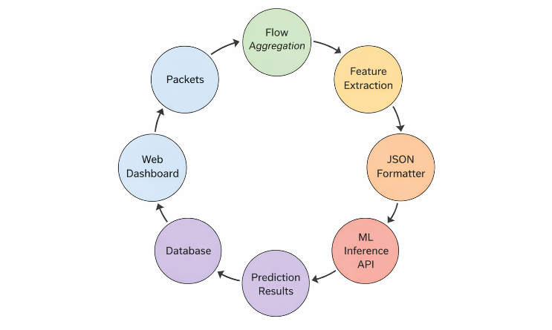
The proposed IDSMS follows a modular, flow-based architecture composed of five primary components: (1) live traffic capture, (2) flow aggregation and feature extraction, (3) machine learning-based intrusion analysis, (4) centralized data storage, and (5) web-based visualization and threat management. Figure 1 illustrates the complete system workflow, from packet capture to security decision-making.

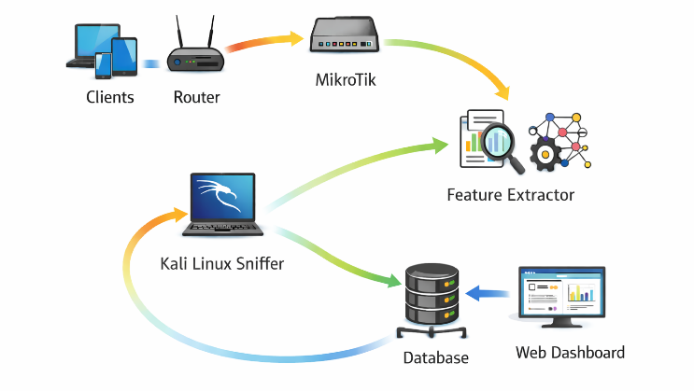
Figure 1. Overall System Architecture Diagram
Network traffic originates from client devices connected to routers and passes through a MikroTik gateway. A dedicated monitoring node running Kali Linux captures and processes traffic flows without interfering with network operations.
Live Traffic Capture and Flow Aggregation
Traffic capture is performed using a Python-based flow sniffer deployed on the Kali Linux virtual machine. The sniffer passively listens on the designated network interface connected to the MikroTik router. Packets are aggregated into bidirectional flows using a five-tuple identifier consisting of source IP address, destination IP address, source port, destination port, and transport protocol.
Flow-based monitoring is selected due to its proven effectiveness in detecting network anomalies while remaining compatible with encrypted traffic [1], [3]. Idle timeout mechanisms are employed to determine flow termination, ensuring timely feature export for real-time analysis.
Feature Extraction and Preprocessing
For each completed flow, the system extracts a comprehensive set of approximately 78 statistical features, following best practices in flow-based IDS research [4], [7], [10]. These features capture temporal, volumetric, and directional characteristics of traffic, including flow duration, packet counts, byte rates, inter-arrival times, and forward–backward packet statistics.
Figure 2. Runtime Data Processing Pipeline of the Proposed IDSMS

Prior to analysis, flows are filtered to remove incomplete or insignificant traffic, such as flows with insufficient packet counts. Feature normalization is applied to ensure compatibility with the trained machine learning models and to prevent dominance of high-magnitude features during inference.
Machine Learning Model Design and Training
The intrusion detection engine integrated into the proposed IDSMS employs a two-stage ensemble machine learning architecture. Stage A performs binary classification to distinguish benign and malicious traffic using a calibrated stacking ensemble composed of Random Forest, Gradient Boosting, and XGBoost classifiers, with Logistic Regression as the meta-classifier. Stage B performs multi-class attack classification using a Random Forest classifier trained exclusively on malicious traffic samples.
The models were trained offline using the CIC-IDS2017 dataset, which contains realistic benign and attack traffic flows represented by 78 numerical flow-based features. Prior to training, feature normalization was applied using standard scaling, and identifier-based fields such as IP addresses and ports were removed to prevent information leakage.
Probability calibration and threshold optimization were applied in Stage A to improve detection reliability under class imbalance. The trained models were then deployed as an inference service and integrated into the proposed system through an API, enabling real-time classification of live network flows.
Machine Learning-Based Intrusion Analysis
Extracted flow features are transmitted to a remote machine learning inference service through a secure API. The detection engine employs supervised learning models trained on labeled flow-based intrusion datasets, enabling classification of traffic into benign or malicious categories.
The inference service outputs a risk level, attack probability, and predicted attack type, consistent with modern IDS frameworks that emphasize probabilistic decision-making rather than binary classification [6], [14], [22]. This decoupled design allows independent updating of detection models without modifying the traffic capture layer.
Data Storage and Logging Mechanism
All analyzed flows and prediction results are stored in a centralized database. Each record includes flow metadata, extracted statistical features, predicted risk classification, probability score, and timestamp. This persistent storage supports forensic analysis, trend evaluation, and system performance assessment.
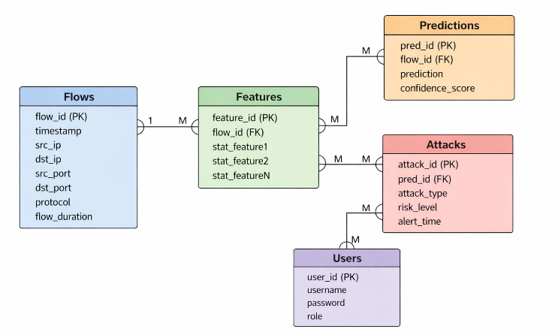
Figure 3 presents the database schema used by the proposed IDSMS. Captured network flows are stored with their extracted statistical features and corresponding prediction outputs. The schema supports traceability between observed traffic, model decisions, and logged security events, enabling real-time dashboard updates and retrospective forensic analysis. The ER diagram represents the logical data model; implementation may store selected fields in a consolidated logging table to simplify real-time insertion and dashboard querying.

Figure 3. Database Schema of the Proposed IDSMS
Flow-level logging aligns with recent IDS research advocating standardized and structured data storage to improve transparency and reproducibility [4], [12].
Web-Based Visualization and Threat Management
A web-based Intrusion Detection and Security Management System (IDSMS) provides real-time and historical insights into network activity. The dashboard displays key metrics such as total network flows, detected attacks, attack rate, and risk-level distribution. Visual components include time-series graphs, attack distribution charts, and top attacked IP summaries.
Detected threats are presented with associated source IP addresses, destination IPs, protocol types, and attack classifications. Administrative controls enable operators to review, manage, and respond to threats, supporting practical deployment scenarios in public and enterprise networks.
Experimental Deployment Environment
The system is deployed in a virtualized environment using VMware. The Kali Linux monitoring node operates alongside the MikroTik gateway, routers, and client devices generating both benign and simulated attack traffic. This setup ensures that captured flows closely reflect real-world network behavior while allowing controlled experimentation.
Such deployment-focused evaluation addresses a key limitation identified in prior IDS studies, which often lack real-time operational validation [4], [23].
SYSTEM ARCHITECTURE AND DESIGN
Overall System Architecture
The proposed Intrusion Detection and Security Management System (IDSMS) is designed using a modular and layered architecture to support real-time network monitoring, scalable analysis, and centralized security management. The architecture separates traffic acquisition, intrusion analysis, data storage, and visualization into independent components, ensuring flexibility, maintainability, and ease of deployment.
The system operates within a gateway-based network environment where client devices connect through routers and a MikroTik gateway. Traffic generated by client devices is passively observed by a dedicated monitoring node, enabling intrusion detection without disrupting normal network operations.
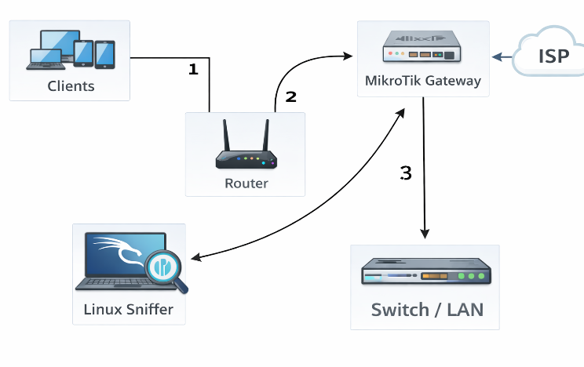
Figure 4. Network Deployment Topology
Network Layer and Traffic Flow
At the network layer, client devices such as mobile phones, laptops, and public-access terminals generate traffic that traverses downstream routers before passing through the MikroTik gateway. This gateway acts as the central routing point and reflects typical configurations used in small enterprises, internet cafés, and pisonet Wi-Fi services.
The MikroTik router provides IP addressing, network address translation (NAT), and routing functions. Importantly, the IDS does not rely on MikroTik’s internal packet inspection; instead, it observes traffic externally to avoid performance degradation and configuration complexity on the gateway device.
Flow Monitoring and Capture Design
A Kali Linux-based monitoring node is connected to the same local network segment as the MikroTik gateway. This node runs a Python-based flow sniffer that captures packets passively from the designated network interface. The sniffer aggregates packets into bidirectional network flows using a five-tuple identifier composed of source IP address, destination IP address, source port, destination port, and transport protocol.
To ensure accurate detection of client-originated threats, the system supports configurable filtering rules that exclude infrastructure-related traffic, such as router management packets and monitoring host traffic. This design ensures that analysis focuses on user-generated traffic, which is critical in shared-access network environments.
Flow Representation and Feature Layer
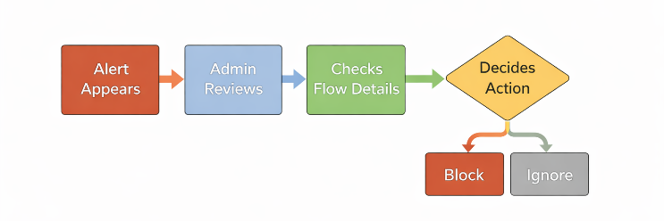
Each completed flow is transformed into a structured feature vector representing statistical properties of the communication session. The system extracts approximately 78 flow-level features, including duration metrics, packet and byte counts, packet rates, inter-arrival times, and directional flow statistics.
This feature-based representation abstracts away packet payloads, enabling compatibility with encrypted traffic and reducing privacy concerns. The feature design aligns with established flow-based intrusion detection practices and supports consistent input to the machine learning inference layer.
Machine Learning Inference Integration
The intrusion analysis component is implemented as a remote machine learning inference service accessed through a secure API. Extracted flow features are transmitted from the monitoring node to the inference service, where trained models classify each flow as benign or malicious.
The inference service returns structured outputs including predicted risk level, probability of attack, and attack category. By decoupling traffic capture from model inference, the system allows independent updates to detection models without modifying the monitoring infrastructure. This architectural choice supports scalability and long-term system evolution.
Data Storage and Logging Architecture
All analyzed flows and prediction results are stored in a centralized relational database. Each database record includes flow metadata, extracted features, classification results, and timestamps. Centralized storage enables historical analysis, auditing, and system performance evaluation.
This logging architecture supports both real-time monitoring and retrospective investigation, addressing operational requirements for network administrators and security analysts.
Web-Based Security Management Interface
A web-based dashboard serves as the system’s visualization and management layer. The interface provides real-time summaries of network activity, including total flows processed, detected attacks, and traffic trends. Graphical elements such as charts and tables enable intuitive analysis of security events.
Administrators can inspect individual flow records, review detected threats, and analyze historical patterns. The dashboard is designed to support decision-making rather than automated enforcement during development, allowing administrators to validate detection behavior before enabling response actions.
Figure 5 illustrates the operational workflow of the security analyst or administrator when handling detected intrusion events. After an alert appears on the dashboard, the administrator reviews the event, inspects the corresponding flow details, and decides whether to block the source or ignore the alert. This workflow highlights the role of the proposed system not only as a detection platform but also as a security management and decision-support tool.
Figure 5. Security Analyst/Admin Decision-Making Workflow
IMPLEMENTATION
Development Environment and Tools
The proposed Intrusion Detection and Security Management System (IDSMS) was implemented using a combination of networking hardware, virtualization tools, and open-source software frameworks. A MikroTik router running RouterOS served as the network gateway, while the intrusion monitoring component was deployed on a Kali Linux virtual machine hosted in a VMware environment. This setup enabled controlled experimentation while closely emulating real-world deployment conditions.
Python was selected as the primary programming language for system development due to its extensive support for network analysis, machine learning integration, and rapid prototyping. Supporting tools included packet capture libraries, HTTP communication modules, and database connectors, facilitating seamless interaction between system components.
Flow Sniffer Implementation
The flow monitoring component was implemented as a Python-based sniffer executed through the command-line interface of the Kali Linux environment. Packet capture was performed on a designated network interface connected to the MikroTik gateway. The sniffer passively observes live traffic and aggregates packets into bidirectional flows using a five-tuple identifier consisting of source IP address, destination IP address, source port, destination port, and transport protocol.
To prevent interference from infrastructure traffic, configurable environment variables were used to exclude router and monitoring host IP addresses from analysis. Flow termination was determined using idle timeouts and minimum packet thresholds to ensure that only meaningful traffic sessions were exported for analysis.

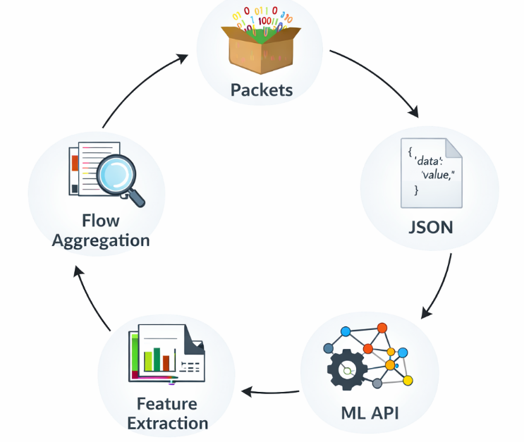
Figure 6. Flow Capture and Feature Extraction Pipeline
Feature Extraction and Flow Processing
For each completed flow, the system computes a comprehensive set of statistical features that characterize the behavior of the communication session. These features include flow duration, packet counts, byte counts, packet rates, inter-arrival times, and directional statistics. Feature extraction is performed locally on the monitoring node to minimize data transmission overhead and ensure real-time performance.
Extracted features are formatted into structured data objects compatible with the machine learning inference service. Basic validation checks are applied to ensure feature completeness before transmission.
Machine Learning API Integration
The machine learning inference component was implemented as an external API service. The monitoring node sends extracted flow features to the API using secure HTTP requests. This service processes the input features using trained machine learning models and returns classification results.
Each response includes the predicted traffic label (benign or malicious), attack probability score, and identified attack type when applicable. This API-based integration allows the detection models to be updated or replaced independently from the flow capture logic, supporting extensibility and continuous improvement.
During development, network connectivity constraints were addressed by configuring appropriate routing and interface modes to ensure reliable communication between the monitoring node and the inference service.
Database and Data Management Implementation
A centralized relational database was used to store analyzed flows and prediction results. Each database entry includes flow identifiers, extracted statistical features, prediction outputs, and timestamps. The database schema was designed to support efficient querying for real-time dashboard updates and historical analysis.
Data persistence enables tracking of network behavior over time and supports post-analysis of detected threats. This storage layer plays a critical role in validating detection performance during development and testing.
Web-Based Dashboard Implementation
A web-based security dashboard was developed to provide visualization and management capabilities. The dashboard displays real-time statistics such as total flows processed, detected attacks, attack rates, and risk-level distributions. Interactive tables allow administrators to inspect individual flow records and review detection results.
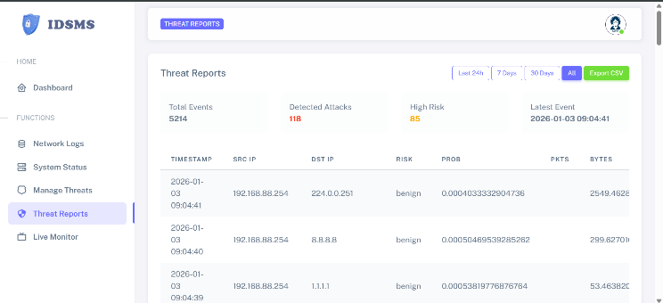
Figure 7. Threat Reports module of the IDSMS showing summarized statistics and per-flow event records.
The interface was designed with development-stage validation in mind, emphasizing transparency and interpretability rather than automated enforcement. This approach allows system behavior to be closely monitored and verified before enabling active response mechanisms.
Testing and Development Configuration
Testing was conducted using a combination of normal network activities and simulated attack traffic. Generated traffic patterns were used to validate flow capture accuracy, feature extraction correctness, API communication, and database logging. These tests confirmed that the system components operate cohesively under development conditions.
The implementation supports future integration of automated mitigation actions, such as blocking malicious IP addresses through the MikroTik router, although such enforcement mechanisms were not enabled during the development phase.
RESULTS AND DISCUSSION
Overview of Development-Stage Results
This section presents and discusses the results obtained during the development and functional testing phase of the proposed Intrusion Detection and Security Management System (IDSMS). The evaluation focuses on validating system functionality, data flow correctness, and integration performance rather than benchmarking detection accuracy against large-scale real-world datasets.
The network traffic used in this phase consisted of a mixture of benign activities and intentionally generated attack traffic designed to test the system’s capability to capture, analyze, classify, and store flow-level information. The results demonstrate that the system operates as intended across all architectural layers, from live traffic capture to dashboard visualization.
Flow Capture and Traffic Visibility
During testing, the flow sniffer successfully captured live traffic traversing the MikroTik gateway and aggregated packets into bidirectional flows. Each flow was uniquely identified using source IP address, destination IP address, source port, destination port, and protocol.
The system consistently recorded flow metadata such as flow duration, packet count, and byte volume. The presence of multiple distinct source IP addresses in the captured data confirms that the system is capable of differentiating traffic generated by individual client devices. This behavior is essential for deployment in shared-access environments, such as pisonet Wi-Fi services, where multiple users generate concurrent traffic.
The successful extraction of flow-level statistics aligns with findings in flow-based IDS literature, which emphasize the reliability of flow representations for real-time monitoring and anomaly detection [1], [3].
Real-Time Monitoring Performance
The real-time monitoring capability of the proposed system is shown in Figure 8. The Live Monitor interface displays current incoming flows, packet rates, and alert counters, and updates continuously as traffic is observed from the network. The interface provides immediate visibility into ongoing network activity, allowing the administrator to track traffic fluctuations and verify that the monitoring and flow capture components are operating correctly. During testing, changes in traffic volume were instantly reflected in the live chart and counters, confirming that the system is capable of processing and visualizing network data in real time. This real-time feedback is essential for operational environments, as it enables rapid situational awareness and supports timely detection of abnormal traffic behavior.
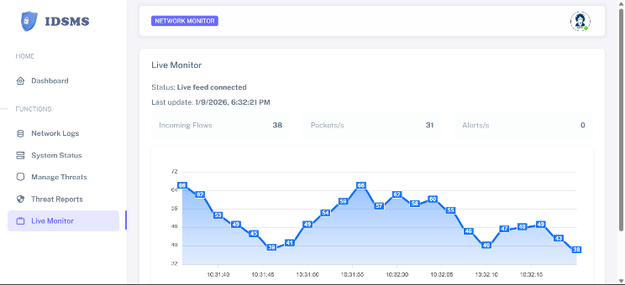
Figure 8. Real-time monitoring interface of the proposed IDSMS showing live flow rate and packet activity.
Feature Generation and Statistical Metrics
For each completed flow, the system generated a structured feature vector consisting of approximately 78 statistical attributes. Key computed metrics included flow duration, packets per second, bytes per second, forward and backward packet counts, and inter-arrival time statistics.
The consistency of these metrics across repeated traffic patterns indicates that the feature extraction process is stable and deterministic. During simulated attack scenarios, abnormal traffic behaviors—such as unusually high packet rates or short inter-arrival times—were reflected in elevated flow-level metrics, demonstrating the sensitivity of the feature set to anomalous behavior.
This result supports prior research indicating that statistical flow features are effective descriptors for distinguishing benign and malicious traffic patterns [4], [10].
Machine Learning Inference Results
Extracted flow features were successfully transmitted to the machine learning inference API and processed without data loss. The inference engine returned prediction results including traffic classification (benign or malicious), probability scores, and identified attack types.
During development testing, most flows were classified as benign, while simulated attack traffic produced elevated probability scores and corresponding attack labels. Although these results do not represent real-world attack prevalence, they confirm that the inference pipeline correctly processes input features and returns interpretable outputs.
The probabilistic output format enables nuanced risk assessment rather than rigid binary decisions, which is consistent with modern IDS design principles [6], [14].
Detection Performance of the Integrated Machine Learning Engine
The integrated two-stage ensemble detection engine, which was previously trained and evaluated using the CIC-IDS2017 dataset, achieved strong performance. In the present system, the trained model was integrated and validated at the functional level using simulated attack traffic. Stage A (binary classification) achieved an accuracy of 99.92% with a ROC-AUC score of 0.99987, indicating near-perfect separation between benign and malicious traffic. Stage B (multi-class classification) achieved an overall accuracy of 99.83% across fourteen attack categories.
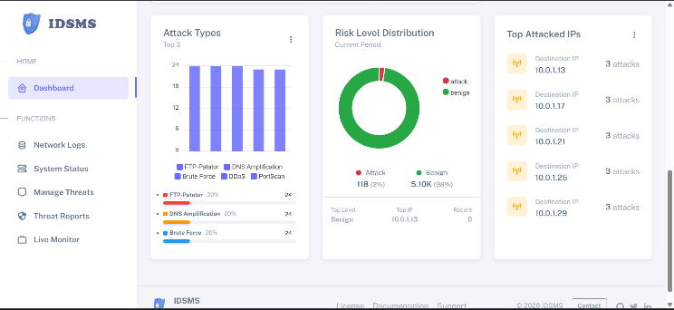
These results confirm that the machine learning component of the proposed IDSMS is not merely a conceptual module but a validated and high-performing detection engine suitable for real-time deployment. It should be noted that these quantitative performance results were obtained during offline training and evaluation of the detection models, while the present system-level experiments focus on validating real-time integration, data flow correctness, and operational functionality.
Table 1. Detection Performance of the Integrated Machine Learning Engine
Stage | Task | Accuracy | ROC-AUC
Stage A | Binary (Benign vs Attack) | 99.92% | 0.99987
Stage B | Multi-class (14 attack types) | 99.83%

Table 1 presents the performance of the two-stage ensemble machine learning engine integrated into the proposed IDSMS. Stage A, which performs binary classification between benign and malicious traffic, achieved an accuracy of 99.92% with a ROC-AUC score of 0.99987, indicating near-perfect discrimination capability. Stage B, which performs multi-class classification among fourteen attack types, achieved an overall accuracy of 99.83%, demonstrating that the system is not only effective at detecting malicious traffic but also reliable in identifying specific attack categories, making it suitable for real-time intrusion detection and security monitoring.
Database Logging and Data Integrity
All analyzed flows and corresponding prediction results were successfully stored in the centralized database. Each record included flow identifiers, extracted features, classification outputs, and timestamps.
Database inspection confirmed that data fields were populated correctly and consistently across multiple test runs. This persistent storage enables historical analysis and supports forensic review of detected events. The ability to store both benign and malicious flow records ensures comprehensive visibility into network behavior.
The logging mechanism adheres to best practices recommended for real-time IDS deployment, where traceability and auditability are critical [12].
Dashboard Metrics and Visualization Analysis

The web-based dashboard provided real-time visualization of network activity and detection outcomes. Metrics such as total flows processed, number of detected attacks, and attack rate were displayed using graphical components.

Figure 9. Dashboard Screenshot (Overview Page)
Time-series graphs illustrated fluctuations in traffic volume and attack occurrences, while tabular views enabled detailed inspection of individual flow records. During simulated attack periods, the dashboard reflected corresponding increases in detected attack counts, confirming synchronization between the monitoring, analysis, and visualization layers
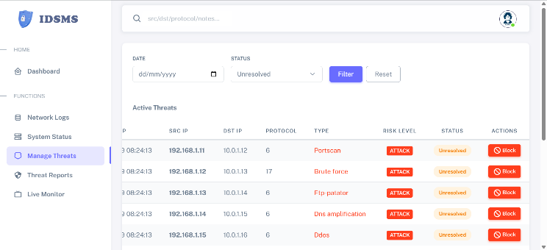
Figure 10: Sample table of Detected Testing Attacks
Because the attack traffic was artificially generated for testing, the displayed attack statistics should not be interpreted as indicative of real-world network conditions. Instead, they demonstrate the system’s ability to surface and contextualize security events during development.
Discussion of System Effectiveness
The results confirm that the proposed IDSMS effectively integrates flow-based traffic monitoring, machine learning-based analysis, and centralized security management. The system demonstrates reliable end-to-end operation, from packet capture through prediction and visualization.
Compared to prior studies that focus primarily on offline datasets and isolated detection models [4], [10], this work emphasizes operational deployment and system integration. The development results indicate that the architecture is suitable for real-world environments, where continuous traffic monitoring and actionable insights are required.
However, the current evaluation is limited to development-scale testing with simulated attacks and a constrained number of client devices. Large-scale deployment with diverse traffic patterns and genuine attack scenarios is identified as a necessary next step to fully assess detection accuracy and scalability.
CONCLUSION AND FUTURE WORK
Conclusion
This study presented the development and implementation of a real-time, flow-based Intrusion Detection and Security Management System (IDSMS) that integrates live network traffic monitoring, machine learning-based intrusion analysis, centralized data storage, and web-based visualization. Unlike many existing IDS studies that focus primarily on offline datasets and model accuracy, this work emphasized system-level design and operational deployment, demonstrating how flow-based intrusion detection can be implemented in a practical network environment.
The system successfully captured live traffic from a MikroTik-based network, aggregated packets into bidirectional flows, extracted statistical features, and transmitted these features to a machine learning inference service for classification. The results were persistently stored in a database and presented through an interactive dashboard, enabling real-time monitoring and historical analysis. Development-stage testing using simulated attack traffic confirmed that the system components function cohesively and that intrusion events are correctly detected, logged, and visualized.
Overall, the findings validate the feasibility of deploying a modular, flow-based IDS capable of supporting shared-access network environments such as pisonet Wi-Fi services, small enterprises, and IoT-enabled infrastructures. The proposed system provides a solid foundation for real-world intrusion detection by combining research-driven methodologies with practical engineering implementation.
Limitations
Although the system demonstrates correct functionality and integration, the evaluation was conducted under development-stage conditions using simulated attack traffic and a limited number of client devices. As such, the results do not fully represent large-scale operational environments with diverse traffic patterns and real-world attack behaviors. Additionally, automated response mechanisms, such as real-time blocking or quarantine of malicious devices, were intentionally disabled during development to prioritize validation and system stability.
Future Work
Future research and development will focus on extending the system’s capabilities and evaluating its performance under real-world conditions. This includes deployment in shared-access environments similar to those studied in recent Pisonet traffic analyses [25], [26], to validate detection robustness under diverse and dynamic user behaviors. Planned enhancements include large-scale deployment involving multiple client devices and prolonged monitoring periods to assess scalability, detection accuracy, and system robustness. Integrating automated mitigation mechanisms, such as dynamic firewall rule enforcement through the MikroTik router, will enable real-time response to detected threats.
Further work will also explore adaptive and federated learning approaches to continuously improve detection models while preserving data privacy. Expanding the system to support additional network environments, including cloud-based and distributed infrastructures, represents another promising direction. Finally, comprehensive benchmarking against established IDS datasets and comparative evaluation with existing systems will be conducted to quantify performance gains and validate detection effectiveness.
REFERENCES
[1]. Satheesh, N., Rathnamma, M. V., Rajeshkumar, G., et al. (2020). Flow-based anomaly intrusion detection using machine learning model with software defined networking for OpenFlow network. Microprocessors and Microsystems, 79, 103285. https://doi.org/10.1016/j.micpro.2020.103285 ScienceDirect
[2]. Pontes, C. F. T., de Souza, M. M. C., Gondim, J. J. C., Bishop, M., & Marotta, M. A. (2021). A New Method for Flow-Based Network Intrusion Detection Using the Inverse Potts Model. IEEE Transactions on Network and Service Management, 18(2), 1125–1136. https://doi.org/10.1109/TNSM.2021.3075503 ResearchGate+1
[3]. Segura-Garcia, J., Garcia-Pineda, M., & Felici-Castell, S. (2021). HeaderHunter: A flow-based, real-time intrusion detection system for IEEE 802.11 networks. Sensors, 21(4), 1140. https://doi.org/10.3390/s21041140 ScienceDirect
[4]. Sarhan, M., Layeghy, S., & Portmann, M. (2022). Towards a Standard Feature Set for Network Intrusion Detection System Datasets. Mobile Networks and Applications, 27(1), 357–370. https://doi.org/10.1007/s11036-021-01843-0 ACM Digital Library+1
[5]. Ferrag, M. A., Friha, O., Hamouda, D., Maglaras, L., & Janicke, H. (2022). Edge-IIoTset: A New Comprehensive Realistic Cyber Security Dataset of IoT and IIoT Applications for Centralized and Federated Learning. IEEE Access. https://doi.org/10.1109/ACCESS.2022.3165809 semanticscholar.org+1
[6]. Vishwakarma, M., & Kesswani, N. (2022). DIDS: A deep neural network based real-time intrusion detection system for IoT. Decision Analytics Journal, 5, 100142. https://doi.org/10.1016/j.dajour.2022.100142 ScienceDirect+1
[7]. Rathore, H., et al. (2023). An anomaly-based IDS for IoT using NetFlow features and deep learning. Neural Computing and Applications. https://doi.org/10.1007/s00521-023-08376-5 Springer
[8]. Fraihat, S., et al. (2023). Intelligent intrusion detection in IoT networks using NetFlow-based traffic and ML (IoT-focused). Internet of Things. https://doi.org/10.1016/j.iot.2023.100819
[9]. Jablaoui, R., Cheikhrouhou, O., Hamdi, M., & Liouane, N. (2025). Deep learning enabled intrusion detection system for IoT security. EURASIP Journal on Wireless Communications and Networking, 2025(1). https://doi.org/10.1186/s13638-025-02477-6
[10]. Kurniabudi, Stiawan, D., Darmawijoyo, Idris, M. Y., & Bamhdi, A. M. (2020). CICIDS-2017 Dataset Feature Analysis with Information Gain for Anomaly Detection. IEEE Access, 8, 132911–132921. https://doi.org/10.1109/ACCESS.2020.3009843 Scinapse
[11]. Maseer, Z. K., Yusof, R., Bahaman, N., Mostafa, S. A., & Foozy, C. F. M. (2021). Benchmarking of Machine Learning for Anomaly Based Intrusion Detection Systems in the CICIDS2017 Dataset. IEEE Access, 9, 22351–22370. https://doi.org/10.1109/ACCESS.2021.3056614 semanticscholar.org
[12]. Komisarek, M., & Pawlicki, M. (2022). A novel, refined dataset for real-time Network Intrusion Detection. In Proceedings of the 17th International Conference on Availability, Reliability and Security (ARES 2022). https://doi.org/10.1145/3538969.3544486 ACM Digital Library
[13]. de Oliveira, J. A., Gonçalves, V. P., Meneguette, R. I., de Sousa Jr, R. T., Guidoni, D. L., Oliveira, J. C. M., & Rocha Filho, G. P. (2023). F-NIDS — A Network Intrusion Detection System based on federated learning. Computer Networks, 236, 110010. https://doi.org/10.1016/j.comnet.2023.110010
[14]. Mohammad, R., Saeed, F., Almazroi, A. A., Alsubaei, F. S., & Almazroi, A. A. (2024). Enhancing Intrusion Detection Systems Using a Deep Learning and Data Augmentation Approach. Systems, 12(3), 79. https://doi.org/10.3390/systems12030079 MDPI
[15]. Alitbi, Z. K., Hosseini Seno, S. A., Ghaemi Bafghi, A., & Zabihzadeh, D. (2025). A Generalized and Real-Time Network Intrusion Detection System Through Incremental Feature Encoding and Similarity Embedding Learning. Sensors, 25(16), 4961. https://doi.org/10.3390/s25164961
[16]. Mutambik, I. (2024). An efficient flow-based anomaly detection system for enhanced security in IoT networks. Sensors, 24(22), 7408. https://doi.org/10.3390/s24227408 PubMed
[17]. Callegari, C., Giordano, S., & Pagano, M. (2024). A real-time deep learning-based approach for detecting network attacks. Big Data Research, 36, 100446. https://doi.org/10.1016/j.bdr.2024.100446 ResearchGate
[18]. Gheni, H. Q., & Al-Yaseen, W. L. (2024). Two-step data clustering for improved intrusion detection system using CICIoT2023 dataset. e-Prime – Advances in Electrical Engineering, Electronics and Energy, 9, 100673. https://doi.org/10.1016/j.prime.2024.100673 ScienceDirect
[19]. Sayed, N., Baskar, S., Ramachandran, M., et al. (2023). Augmenting IoT intrusion detection system performance using deep neural network. CMC—Computers, Materials & Continua, 74(1). https://doi.org/10.32604/cmc.2023.030831 techscience.com
[20]. Manocchio, L. D., Layeghy, S., Lo, W. W., et al. (2023). FlowTransformer: A transformer framework for flow-based network intrusion detection systems. Expert Systems with Applications, 241, 122564. https://doi.org/10.1016/j.eswa.2023.122564 ResearchGate
[21]. Doriguzzi-Corin, R., & Siracusa, D. (2023). FLAD: Adaptive federated learning for DDoS attack detection. Computers & Security, 137, 103597. https://doi.org/10.1016/j.cose.2023.103597 ResearchGate
[22]. Nugraha, K. D., Kota, V. R., & Rupp, M. (2024). Leveraging federated learning and variational autoencoders for an enhanced anomaly detection system. IEEE NetSoft 2024. https://doi.org/10.1109/NetSoft60951.2024.10588934 ResearchGate
[23]. Devine, M., Ardakani, S. P., Al-Khafajiy, M., & James, Y. (2025). Federated machine learning to enable intrusion detection systems in IoT networks. Electronics, 14(6), 1176. https://doi.org/10.3390/electronics14061176 MDPI
[24]. Buyuktanir, O., Nandi, D., & Goyal, N. (2025). A review of federated learning applications in intrusion detection systems. Cluster Computing. https://doi.org/10.1007/s10586-025-05325-w
[25] Saligue, R. Y., & Saligue, E. T. (2025). Real-World Traffic Analysis in Pisonet using DTW and Anomaly Detection. In 2025 7th International Conference on Innovative Data Communication Technologies and Application (ICIDCA). IEEE.
https://doi.org/10.1109/ICIDCA66325.2025.11280496
[26] Saligue, R. Y., Saligue, E. T., Teofilo, L. M., Sy, K. N. L., & Cerna, P. D. (2025). Dynamic Analysis and Visualization of Network Traffic Patterns using Machine Learning and Seasonal Decomposition Techniques. In 2025 5th International Conference on Soft Computing for Security Applications (ICSCSA). IEEE.
https://doi.org/10.1109/ICSCSA66339.2025.11170757

